**CANCEL REQUEST FORM**

**PROD Manager’s Manual**

1. **Go to** [**http://10.27.1.170:9292/default.aspx**](http://10.27.1.170:9292/default.aspx) **and login your account.**

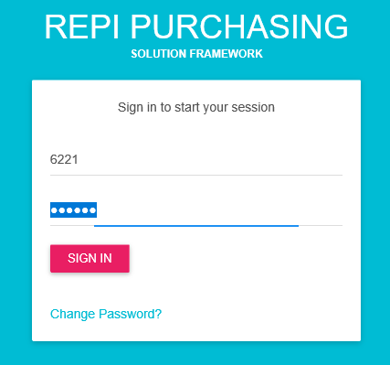

**My Dashboard display you’re “for approvals” based on your user access. You can directly click on the CANCEL REQUEST FORM number and it will redirect to the approval form accordingly.**

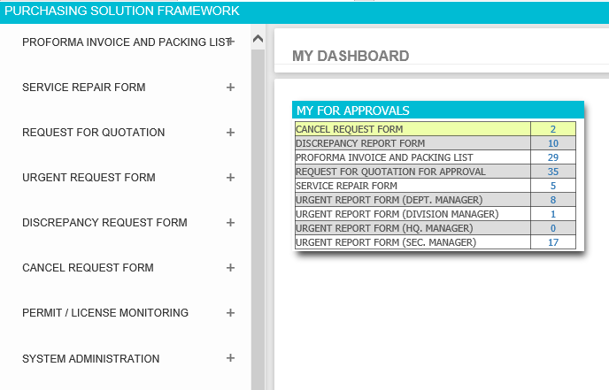

1. **Navigate CANCEL REQUEST FORM then click the positive sign (+) button to see all options assigned to your account.**

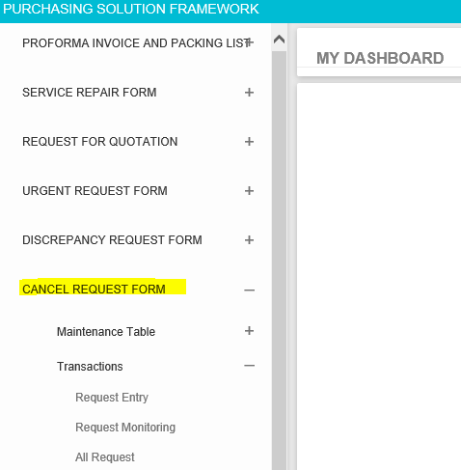

1. **If you want to create new request then go to CANCEL REQUEST FORM > Transactions > Request Entry**

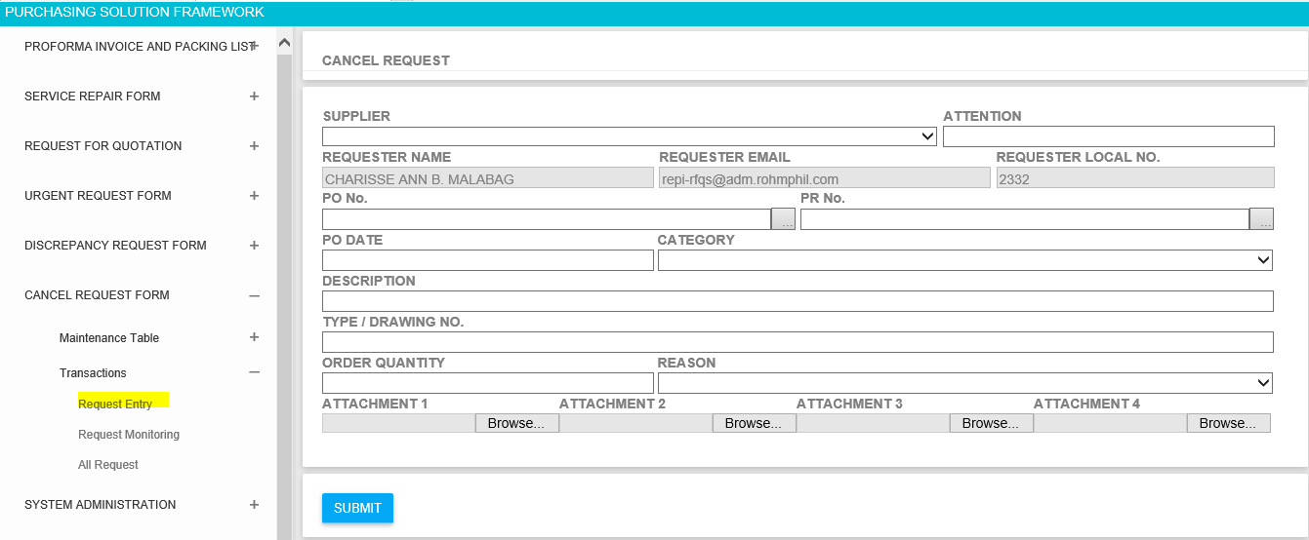

* **3.1 Enter all required field before submitting the request. If you missed to fill up required fields then the system will inform you by marking red colors. See example below;**

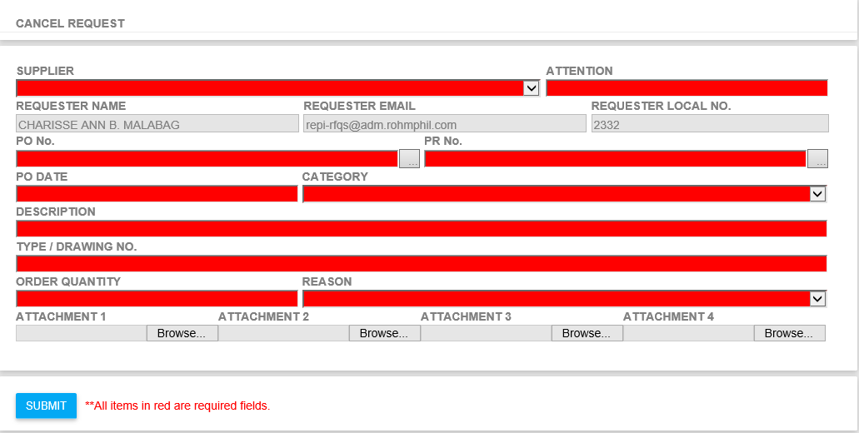

* **3.2 If you have an attachment, please make sure that you finish first all the details before attaching file if there is any. Its like how you do it in RFQ Module.**

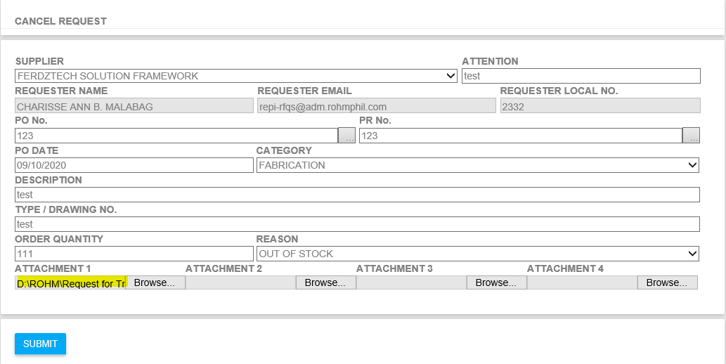

* **3.3 You will be redirected to success page if there is no error after clicking SUBMIT Button**

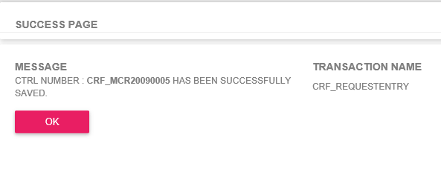

1. **If you want to check or monitor your request the go to CANCEL REQUEST FORM > Transactions > Request Monitoring**

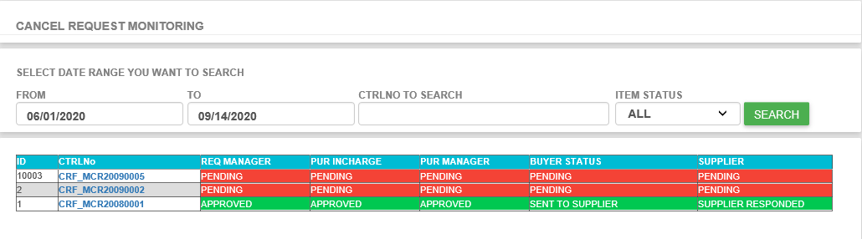

* **4.1 Click CTRL No Number if you want to see the request details.**

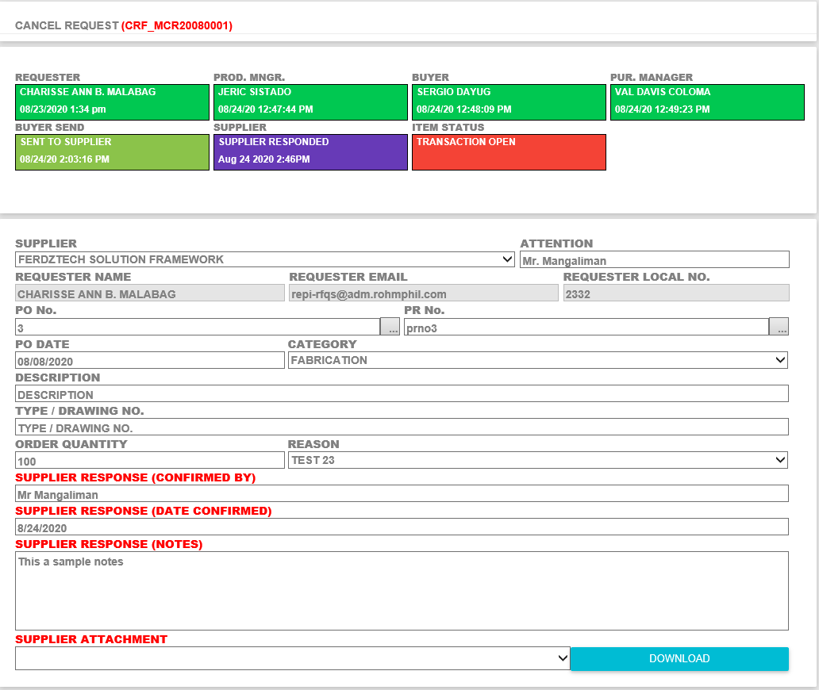

* **4.2 If you missed something on your request then you have chance to update it before your section manager approve the request. Click the DRF Number on the left side then you will be redirected to the request entry to update your request.**

1. **If you want see all request the go to CANCEL REQUEST FORM > Transactions > All Request. This page is almost the same with the RFQ All Request Form for your reference.**

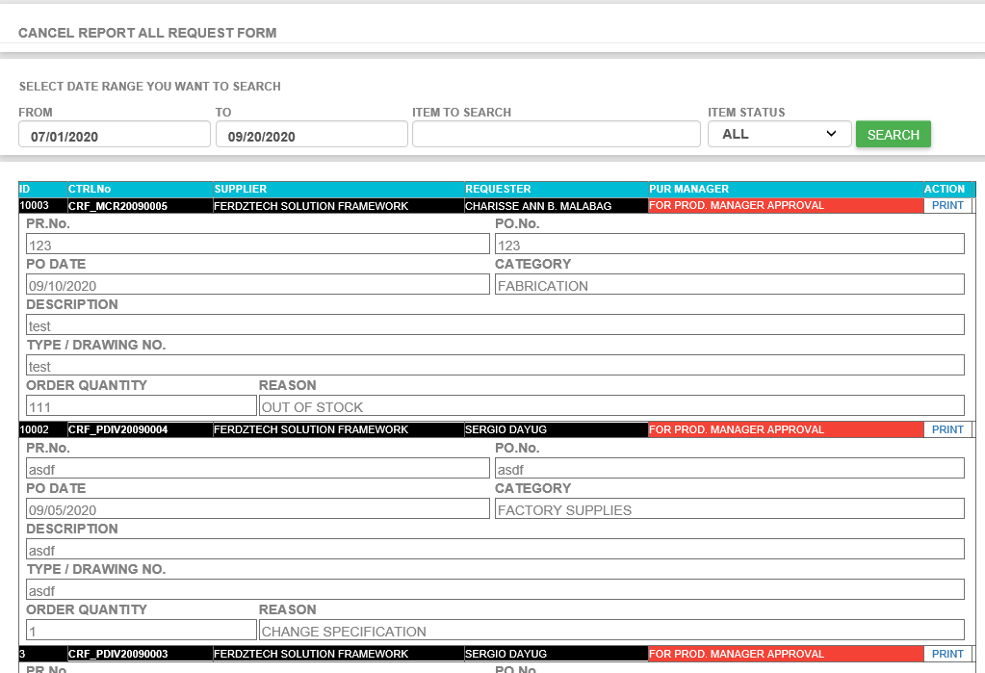

1. **If you want to approved request then go to CANCEL REQUEST FORM > Transactions > Request For Approval**

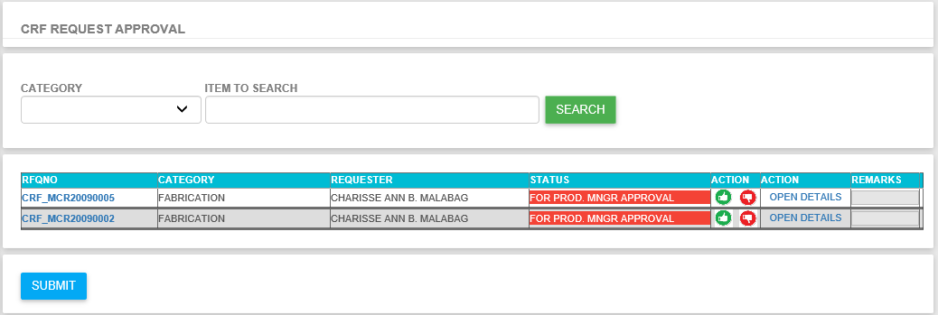

* **6.1 Click OPEN DETAILS if you want to see the request details**

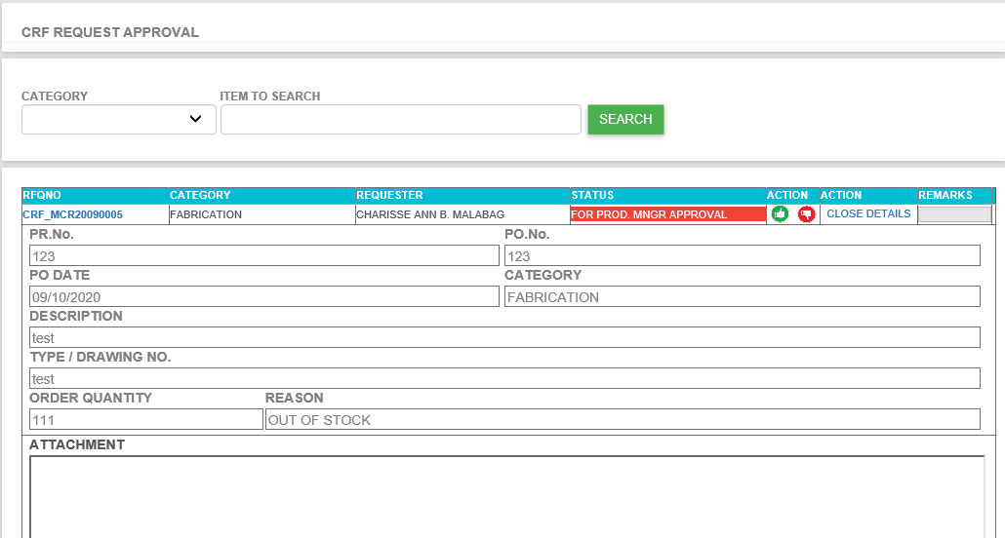

* **6.2 If request is good and ready for approval then click the green thumbs up button in ACTION column then click SUBMIT.**

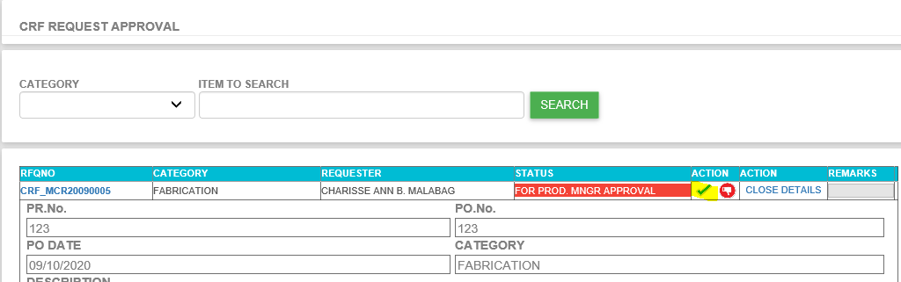

* **6.3 If no error then you will be redirected to successful page.**

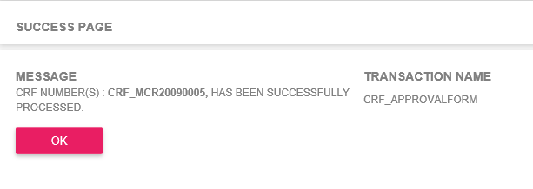

* **6.4 If you want to reject or disapproved request then click the red thumbs down button, add your disapproval remarks then click submit.**

